Initial Testing Report

Near-RT RIC Platform (I Release)

2024-07-17

# Progress so far.

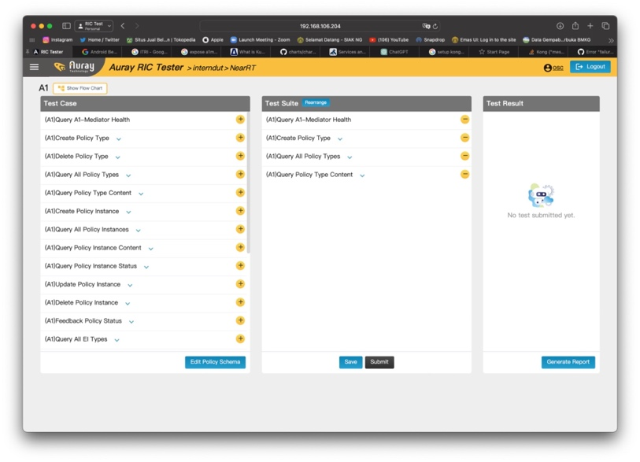

Figure 1 RIC Tester Dasboard

Currently have learned about the how-to for the RIC tester tool and have done initial testing to the existing Near-RT RIC (the one that already deployed)

Figure 2 Testing the new Near-RT RIC

Currently still working on testing the new Near-RT RIC as the DUT.

# Encountered problems

Figure 3 Error message when testing the A1 Interface

The RIC tester cannot access the A1 mediator inside the DUT.

## Possible cause

Initially thought the problem is in the a1mediator itself, but after doing from the same machine using the pod IP it gives the expected response.

ricplt. service-ricplt-a1mediator-http ClusterIP 0.96.102.138 <none> 10000/TCP 8d

Figure 4 Response when using manual GET request to the pod IP

So, it is not likely to be in the a1mediator

Another possibility is with the kong proxy, which handles the routing from the machine IP to the veth interface IP used by the k8s pods.



Figure 5 Kong proxy k8s service

Still need to investigate more about this possibility

### Possible Solution:

* Fixing the kong proxy if the problem is actually in there.
* Use different ingress controller (probablu nginx). But still need to determine if changing the ingress controller will affect the other component, possibly stability or compatibility issues.

Last possibility which discovered after today’s meeting is the with RIC tester.

Figure 6 Healthcheck API from ORAN Docs.

Figure 7 Captured API sent from the RIC tester

Notice on how the route differ between those two. <http://[ip-address]/A1-P/v2/healthcheck> on the ORAN docs vs <http://[ip-address]/A1-P/healthcheck> on the tester. I we use the same route as the RIC tester used it gives 404 response

Figure 8 404 Response when using the same route as the RIC Tester

Whereas when we use route in the ORAN Docs it successfully sent OK response as expected (check Figure 4).

Does the RIC tester needs some reconfiguration first?